海报
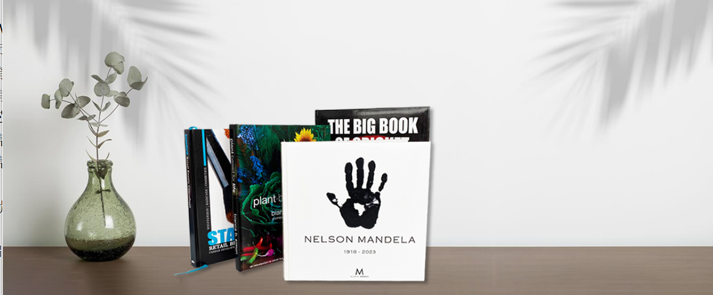
Exquisite, unique, and customized hardcover books are undoubtedly the best representation of your identity as an author, as well as your values and personal style.
精美的，独特的，定制印刷精装书是你的身份，价值观和个人风格作为一个作者的完美声明。

We are committed to producing beautifully crafted and high-quality hardcover books for visionary self-publishers, speakers, entrepreneurs, and businesses. Hardcover books provide a stronger sense of quality and can enhance the image and appeal of a work, especially for those that rely on visual presentation.

With over 20 years of successful industry experience, a professional team, cutting-edge technology, and excellent customer service, we maintain a first-class reputation for mature self-publishers and independent creators worldwide, demonstrating our dedication and commitment to delivering high-quality products.

We strive to establish good relationships with publishers and negotiate contracts to secure distribution rights for hardcover books, giving authors more options. Hardcover books typically convey a sense of high quality and taste. For books that require a strong image, such as promotional materials, graphic novels, and memoirs, using hardcover books can attract readers' attention and enhance brand image.
我们致力于为具有远见的自助出版商、演讲者、企业家和企业制作精美且高品质的精装书。精装书的品质感更强，有助于提高作品的形象和吸引力。尤其是对于那些视觉表现力很重要的作品，精装书的印刷和装帧可以突显作品的特点。
凭借超过20年的成功行业经验、专业团队、尖端技术和卓越的客户服务，我们在全球范围内为成熟的自助出版商和独立创作者保持一流声誉，展现我们的敬业精神和优质产品。
与出版商建立良好的合作关系，争取在合同谈判中为作者争取到精装书的发行权益，让作者有更多的选择权。
精装书通常给人一种高质量、高品味的感觉。对于宣传品、图画小说、回忆录等需要展现良好形象的书籍，使用精装书更能吸引读者的关注，提升品牌形象。
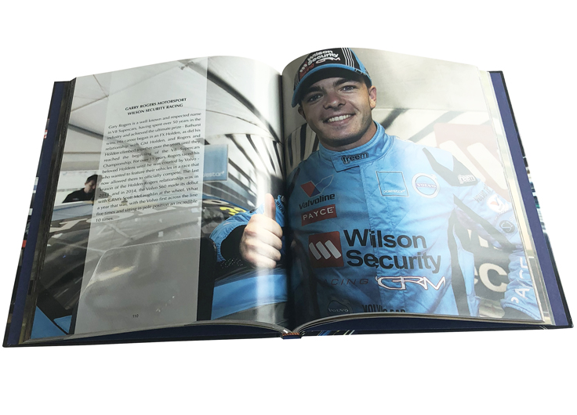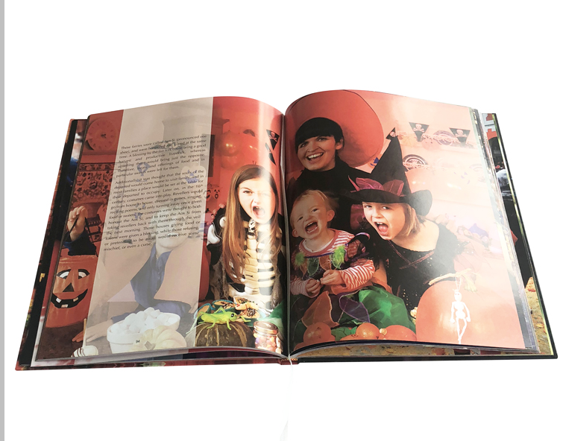
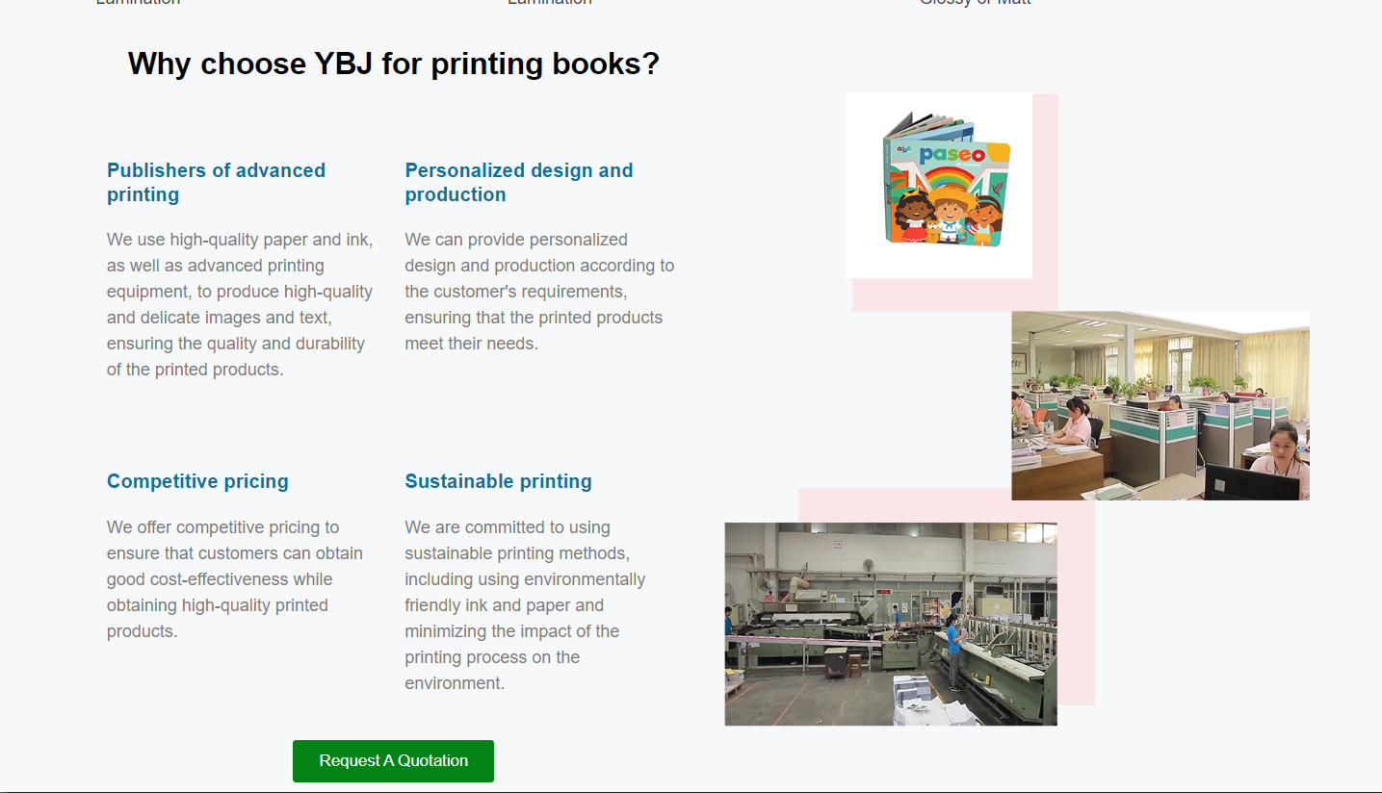
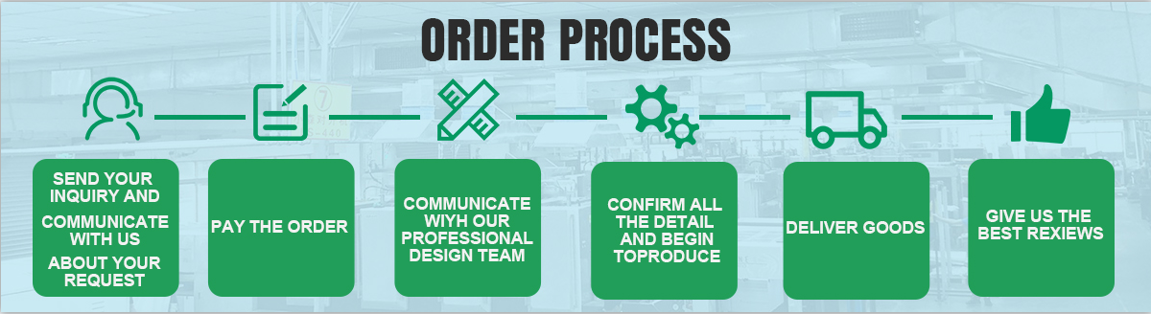
-As a hardcover book production factory, we promise to provide affordable and quality-assured products. We understand that price is one of the important factors that many customers consider when choosing a supplier. Therefore, we have been committed to controlling costs, adopting efficient production processes and technologies to improve efficiency and reduce costs. Based on this, we can offer customers more favorable prices while ensuring that product quality is not compromised.

-Our factory has advanced equipment and a professional team that can meet customers' various needs for hardcover books, from custom sizes to printing options, from inner page paper to cover materials. We can customize them according to customer requirements. At the same time, we also provide a rich selection, which can be selected according to the customer's budget and needs, such as different paper, binding, and printing options, to achieve the desired effect.

-We firmly believe that our price advantage and quality assurance can win customers' trust and satisfaction. Whether you are a self-publisher, speaker, entrepreneur, or business, we will serve you wholeheartedly and create high-quality hardcover book products for you.
-If you have any questions, please contact us, our sales colleagues are engaged in more than 10 years of printing industry experience, please believe in our profession
作为精装书生产工厂，我们承诺提供价格合理，质量有保证的产品。我们理解价格是许多客户在选择供应商时考虑的重要因素之一。因此，我们一直致力于控制成本，采用高效的生产工艺和技术，提高效率，降低成本。基于此，我们可以为客户提供更优惠的价格，同时保证产品质量不打折扣。
我们工厂拥有先进的设备和专业的团队，可以满足客户对精装书籍的各种需求，从定制尺寸到印刷选项，从内页纸到封面材料。我们可以根据客户的要求定制。同时，我们还提供丰富的选择，可以根据客户的预算和需求进行选择，如不同的纸张、装订、印刷选项，以达到想要的效果。
我们坚信我们的价格优势和质量保证能赢得客户的信任和满意。无论您是自营出版人、演说家、企业家、商人，我们都将竭诚为您服务，为您打造高品质的精装图书产品。
如果您有任何疑问，请联系我们，我们的销售同事都有从事印刷行业十多年的经验，请相信我们的专业
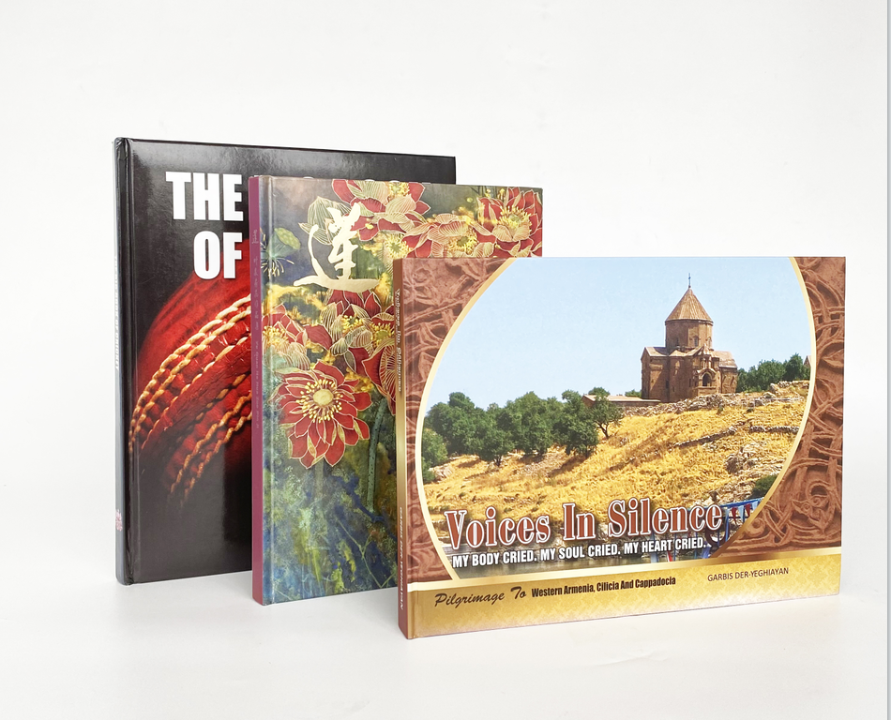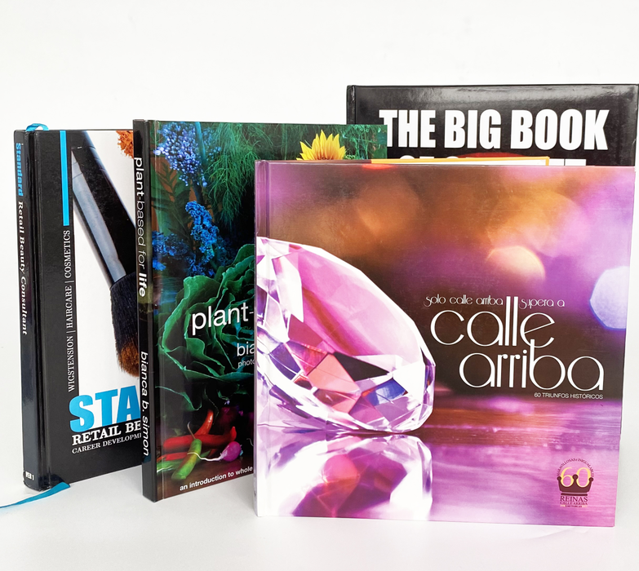

Surface Finishing / Binding Style
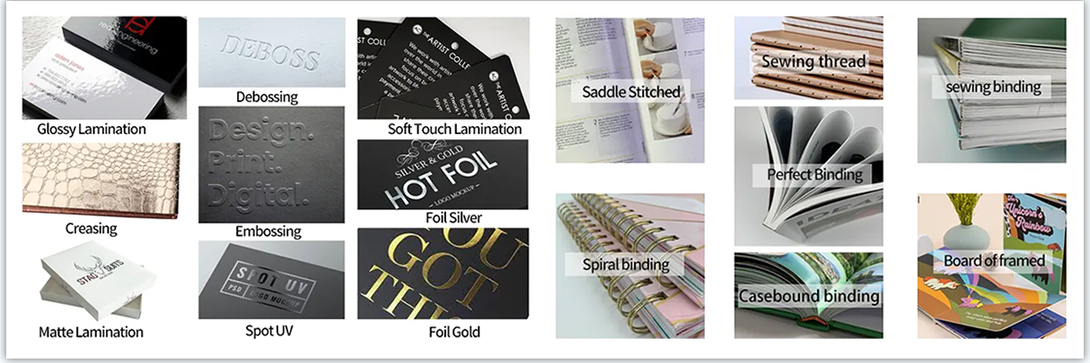
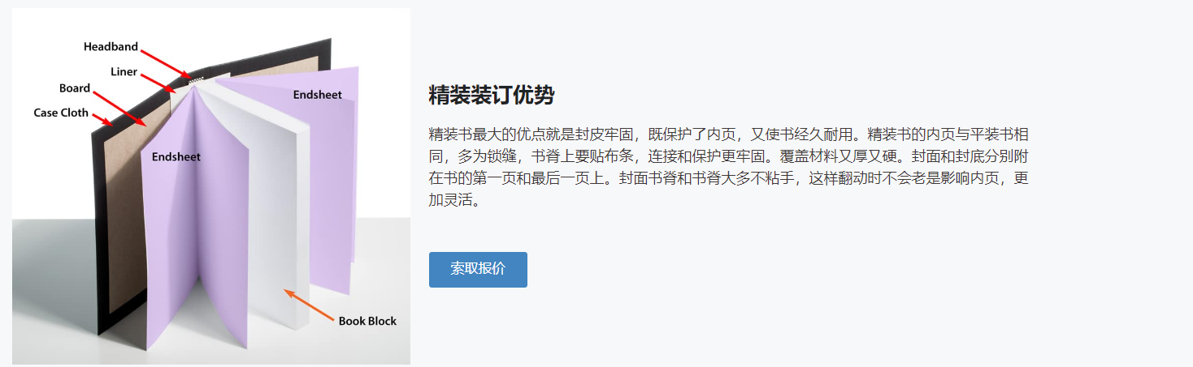

Let’s talk!
